**ABSTRACT**

CardioGuard is a real-time cardiac arrest prediction and alert system that integrates wearable health sensors, machine learning, and cloud-based infrastructure to enable early detection of cardiac anomalies and immediate emergency response. By leveraging AD8232 ECG and SpO₂ sensors connected to an ESP32-based wearable unit, the system continuously monitors a user's physiological signals. A Random Forest classifier, optimized with hyperparameter tuning and K-Fold cross-validation, performs real-time anomaly detection.

Sensor data is transmitted to a Supabase-powered backend via WebSockets, where Supabase Edge Functions and Firebase Cloud Messaging (FCM) coordinate automated emergency alerts. Upon detecting consecutive high-risk patterns, the system dispatches instant notifications—containing severity data and GPS location—to emergency contacts, healthcare providers, and the user via a Progressive Web App (PWA).

With an average end-to-end latency of 90 milliseconds and a 98% model accuracy, CardioGuard demonstrates high reliability in real-time scenarios. The system’s modular, scalable architecture, combined with predictive analytics, enhances patient safety and reduces response time during critical health events. This work showcases a practical, accessible, and intelligent solution for AI-powered remote cardiac monitoring and emergency preparedness.

**TABLE OF CONTENTS**

| **SECTION** | **TITLE** | **PAGE NO.** |
| --- | --- | --- |
|  | CardioGuard – cardiac arrest prediction and alerting system | 1 |
|  | ABSTRACT | 1 |
| **1** | **INTRODUCTION** | – |
|  | 1.1 Project Overview | 10 |
|  | 1.2 Project Purpose | 10 |
|  | 1.3 Project Scope | 11 |
|  | 1.4 Project Features | 12 |
| **2** | **LITERATURE REVIEW** | 14 |
| **3** | **EXISTING & PROPOSED SYSTEM** | 17 |
|  | 3.1 Existing System | 17 |
|  | 3.2 Existing System Disadvantages | 17 |
|  | 3.3 Problem Statement | 18 |
|  | 3.4 Proposed System | 18 |
|  | 3.5 Proposed System Advantages | 20 |
| **4** | **SYSTEM REQUIREMENTS** | 21 |
|  | 4.1 Software Requirements | 21 |
|  | 4.2 Hardware Requirements | 21 |
| **5** | **PROJECT DESCRIPTION** | 23 |
|  | 5.1 Modules | 23 |
| **6** | **SYSTEM DESIGN** | 26 |
|  | 6.1 System Architecture | 26 |
|  | Presentation Layer | 26 |
|  | Application Layer | 26 |
|  | Data Layer | 27 |
|  | Component Interactions | 28 |
|  | Data Flow Design | 29 |
|  | UML Design | 30 |
|  | 6.1.1 Class Diagram | 31 |
|  | 6.1.2 Object Diagram | 32 |
|  | 6.1.3 Component Diagram | 32 |
|  | 6.1.4 Deployment Diagram | 33 |
|  | 6.1.5 Use Case Diagram | 34 |
|  | 6.1.6 Sequence Diagram | 35 |
|  | 6.1.7 Activity Diagram | 36 |
|  | 6.1.8 State Diagram | 37 |
|  | 6.1.9 Timing Diagram | 38 |
| **7** | **SOFTWARE SPECIFICATIONS** | 39 |
|  | 7.1 Frontend Development with HTML, CSS, JavaScript, and PWA | 39 |
|  | 7.2 Supabase Database (PostgreSQL) | 40 |
| **8** | **IMPLEMENTATION** | 42 |
|  | Key Features | 42 |
|  | 8.1 Installation & Setup | 42 |
|  | Prerequisites | 43 |
|  | Step-by-Step Implementation | 43 |
|  | Additional Configuration | 44 |
|  | Code | 45 |
| **9** | **SOFTWARE TESTING** | 46 |
|  | 9.1 Unit Testing | 46 |
|  | 9.2 Integration Testing | 46 |
|  | 9.3 System Testing | 47 |
|  | 9.4 Acceptance Testing | 47 |
|  | 9.5 Performance Testing | 47 |
|  | 9.6 Security Testing | 48 |
|  | 9.7 Compatibility Testing | 48 |
| **10** | **RESULTS** | 49 |
|  | 10.1 Hardware Integration | 49 |
|  | 10.2 Landing Page UI | 50 |
|  | 10.3 User Registration and Authentication | 52 |
|  | 10.4 Sign-Up Details Collection | 54 |
|  | 10.5 Real-Time Monitoring Dashboard | 56 |
| **11** | **CONCLUSION**  11.1 Conclusion  11.2 Future scope | 57  57  58 |
| **12** | **REFERENCES** | 60 |
|  |  |  |

**LIST OF FIGURES**

| **FIGURE NO.** | **FIGURE TITLE** | **PAGE NO** |
| --- | --- | --- |
| Figure 1 | System Architecture | 28 |
| Figure 2 | Data Flow Diagram | 29 |
| Figure 3 | Class Diagram | 30 |
| Figure 4 | Object Diagram | 31 |
| Figure 5 | Component Diagram | 32 |
| Figure 6 | Deployment Diagram | 32 |
| Figure 7 | Use Case Diagram | 33 |
| Figure 8 | Sequence Diagram | 34 |
| Figure 9 | Activity Diagram | 35 |
| Figure 10 | State Diagram | 36 |
| Figure 11 | Timing Diagram | 37 |
| Figure 12 | CardioGuard Hardware Setup | 48 |
| Figure 13–16 | CardioGuard Landing Page UI Screenshots | 49 |
| Figure 17 | Additional Landing Page Screenshot | 50 |
| Figure 18 | Additional Landing Page Screenshot | 51 |
| Figure 19 | User Sign-Up Page | 52 |
| Figure 20 | User Sign-In Page | 53 |
| Figure 21 | Personal Information Form | 54 |
| Figure 22 | Medical Information Form | 54 |
| Figure 23 | Lifestyle Information Form | 55 |
| Figure 24 | Emergency Contact Form | 56 |

**LIST OF ABBREVIATIONS**

|  |  |
| --- | --- |
| **Abbreviation** | **Full Form** |
| AI | Artificial Intelligence |
| ECG | Electrocardiogram |
| SpO₂ | Peripheral Capillary Oxygen Saturation |
| SCA | Sudden Cardiac Arrest |
| ML | Machine Learning |
| PWA | Progressive Web App |
| FCM | Firebase Cloud Messaging |
| GPS | Global Positioning System |
| IoT | Internet of Things |
| EMS | Emergency Medical Services |
| HRV | Heart Rate Variability |
| K-Fold CV | K-Fold Cross-Validation |
| n_estimators | Number of Trees in a Random Forest |
| ESP32 | Espressif Systems 32-bit Microcontroller |
| AD8232 | Analog Devices AD8232 ECG Front End Module |
| .joblib | Joblib Serialized Model File Format |
| UI | User Interface |
| CPU | Central Processing Unit |
| CSV | Comma-Separated Values |
| SMS | Short Message Service |

**CHAPTER 1 INTRODUCTION**

* 1. **PROJECT OVERVIEW**

CardioGuard is a real-time cardiac arrest prediction and emergency alert system designed to continuously monitor a user's heart health using wearable sensors and machine learning. It utilizes AD8232 ECG and SpO₂ sensors connected to an ESP32 microcontroller to gather physiological data, which is transmitted via WebSockets to a backend server. A Random Forest classifier analyzes the data to detect cardiac anomalies and minimize false positives by validating consecutive irregular readings. Once a high-risk pattern is confirmed, the system triggers emergency alerts through email, SMS, and push notifications using Firebase Cloud Messaging (FCM), while GPS coordinates and severity information are shared with registered emergency contacts.

The system is built with a Supabase backend that handles authentication, data storage, and server-side logic through Edge Functions. A Progressive Web App (PWA) serves as the user interface, allowing access to real-time health dashboards across devices. By combining AI-powered anomaly detection with scalable cloud infrastructure and responsive design, CardioGuard provides an accessible and proactive solution to reduce response time during cardiac emergencies, potentially saving lives through early intervention and automated alerting.

* 1. **PROJECT PURPOSE**

The purpose of the CardioGuard project is to design and implement a real-time cardiac health monitoring system that can predict the onset of cardiac arrest and initiate an automated emergency response. Sudden cardiac arrest remains a leading cause of death globally, and timely medical intervention is critical for survival. However, traditional cardiac monitoring methods are often reactive, requiring manual checks and lacking predictive capabilities. CardioGuard aims to bridge this gap by offering a proactive solution that combines wearable health sensors, machine learning algorithms, and cloud-based technologies.

By continuously monitoring ECG and SpO₂ signals through affordable wearable devices, the system detects abnormal patterns indicative of potential cardiac events. A trained Random Forest model performs real-time anomaly detection, and upon identifying repeated anomalies, the system automatically alerts emergency contacts, healthcare professionals, and the user via email, SMS, and push notifications. The project’s purpose extends beyond just monitoring—it seeks to empower users with early warnings, enable faster emergency response, and ultimately reduce cardiac-related fatalities by providing accessible and intelligent health surveillance for at-risk individuals.

* 1. **PROJECT SCOPE**

The scope of the **CardioGuard** project covers the end-to-end development of a real-time, AI-powered cardiac monitoring and emergency alert system designed to reduce response time during cardiac emergencies and improve patient outcomes. The system includes both hardware and software components, starting from data acquisition using wearable ECG (AD8232) and SpO₂ sensors connected to an ESP32 microcontroller. These sensors capture continuous physiological data, which is transmitted in real-time to a cloud-connected backend using WebSockets.

The backend infrastructure, developed using Python and FastAPI, processes incoming sensor data and performs real-time anomaly detection using a pre-trained Random Forest machine learning model. The model is optimized through K-Fold cross-validation and hyperparameter tuning to ensure accurate classification of cardiac anomalies. Upon detecting confirmed high-risk patterns, the system initiates an emergency alert protocol using Supabase Edge Functions and Firebase Cloud Messaging (FCM), sending notifications to registered emergency contacts, healthcare professionals, and the user, along with GPS location and condition severity.

The project also includes a **Progressive Web App (PWA)** that serves as the user interface, allowing users to register, input personal and medical information, view real-stime ECG and SpO₂ data, and receive alerts. The application is designed to be accessible across devices and platforms, ensuring ease of use and responsiveness. The Supabase platform is used to handle authentication, store user and medical data, manage emergency contacts, and maintain incident logs for future reference.

The scope further extends to testing system performance, evaluating model accuracy, analyzing system latency, and verifying alert delivery reliability. However, the current scope does not include advanced biometric tracking beyond ECG and SpO₂, nor does it cover direct medical diagnosis or treatment. Future scope enhancements may include the integration of additional sensors (e.g., blood pressure, temperature), support for commercial smartwatches, deployment of edge AI models directly on microcontrollers, and interoperability with hospital information systems and emergency medical services (EMS).

* 1. **PROJECT FEATURES**
* **Real-Time ECG & SpO₂ Monitoring**

Continuously tracks heart activity and oxygen saturation using AD8232 and SpO₂ sensors.

* **Machine Learning-Based Anomaly Detection**

Utilizes a Random Forest model to detect early signs of cardiac arrest with high accuracy.

* **Consecutive Anomaly Validation**

Triggers alerts only after detecting multiple consecutive anomalies to reduce false positives.

* **Automated Emergency Alerts**

Sends instant notifications to users, doctors, and emergency contacts via email, SMS, and push notifications.

* **GPS-Based Location Sharing**

Includes the user’s location in alerts to help responders locate the patient quickly.

* **Progressive Web App (PWA)**

Cross-platform web interface with real-time data visualization and emergency interaction.

* **Supabase-Powered Backend**

Handles authentication, user profiles, medical data, and incident logs with serverless functions.

* **WebSocket Integration**

Enables low-latency, real-time data transmission between the hardware and backend.

* **Incident Logging**

Automatically stores anomaly events with timestamps, severity, and medical context for review.

* **Scalable and Cost-Effective Architecture**

Designed for deployment across various environments, from personal use to institutional healthcare.

**CHAPTER 2 LITERATURE REVIEW**

Recent advancements in wearable technology, machine learning, and IoT have laid the foundation for real-time health monitoring systems capable of predicting critical medical conditions. Studies have explored the integration of ECG and SpO₂ sensors in wearable devices to enable continuous cardiac monitoring, particularly for early detection of arrhythmias and myocardial infarction. Research by Li et al. (2020) and Sharma et al. (2021) emphasizes the potential of AI models such as Random Forests and Convolutional Neural Networks in accurately detecting anomalies in ECG signals. These approaches have demonstrated strong performance in distinguishing between normal and abnormal heart rhythms, highlighting the feasibility of machine learning in non-invasive, real-time diagnostics.

In parallel, cloud-based platforms and serverless architectures are increasingly being used to manage large volumes of medical data with high availability and scalability. Literature on mobile health systems also discusses the importance of immediate feedback and automated alert mechanisms for improving response time during emergencies. Systems like HealthGuardian and BioWear have shown the effectiveness of integrating wearable sensors with real-time communication technologies. However, most existing implementations lack customizable emergency workflows, integration with user-specific medical histories, and real-time multi-signal analysis—gaps that CardioGuard aims to address. By combining sensor-driven data acquisition, intelligent anomaly detection, and automated emergency alerts through cloud infrastructure, CardioGuard builds upon and extends the capabilities of prior systems in a more accessible and practical framework.

**Context of Papers Referred**

1. **AI-Driven Real-Time Classification of ECG Signals for Cardiac Monitoring Using i-AlexNet Architecture**  
   **Authors**: Manjur Kolhar, Raisa Nazir Ahmed Kazi, Hitesh Mohapatra, Ahmed M Al Rajeh  
   **Published in**: *Diagnostics*, 2024  
   **Summary**: This study presents a continuous ECG monitoring solution using a modified i-AlexNet architecture with red fox optimization. It classifies ECG signals as normal or abnormal with 98.8% accuracy, showcasing the potential of AI and IoMT integration for real-time cardiac monitoring.  
   **Access**: Read on MDPI
2. **AI-CardioCare: Artificial Intelligence-Based Device for Cardiac Health Monitoring**  
   **Authors**: Rakesh Chandra Joshi, Juwairiya Siraj Khan, Vinay Kumar Pathak, Malay Kishore Dutta  
   **Published in**: *IEEE Transactions on Human-Machine Systems*, 2022  
   **Summary**: This paper introduces an AI-based cardiac diagnostic device that uses a custom stethoscope to capture heart sounds. Deep learning is applied to analyze the data and detect cardiac diseases in real time.  
   **Access**: Read on Aalborg University Research Portal
3. **CardioGuard: A Brassiere-Based Reliable ECG Monitoring Sensor System for Supporting Daily Smartphone Healthcare Applications**  
   **Authors**: Sungjun Kwon, Jeehoon Kim, Seungwoo Kang  
   **Published in**: *Journal of Medical Internet Research*, 2014  
   **Summary**: This research proposes a non-intrusive ECG monitoring solution integrated into a brassiere. The system supports continuous daily monitoring and connects with smartphone healthcare applications.  
   **Access**: [Read on PMC](https://www.ncbi.nlm.nih.gov/pmc/articles/PMC4270128/)
4. **AI-Enhanced ECG Applications in Cardiology: Comprehensive Insights from the Current Literature with a Focus on COVID-19 and Multiple Cardiovascular Conditions**  
   **Authors**: Luiza Camelia Nechita, Aurel Nechita, Andreea Elena Voipan, et al.  
   **Published in**: *Diagnostics*, 2024  
   **Summary**: A broad review of AI's impact on ECG applications, highlighting its role in diagnosing cardiovascular diseases including during COVID-19. The study emphasizes improvements in accuracy and response time through AI models.  
   **Access**: Read on MDPI
5. **Transforming Cardiovascular Care with Artificial Intelligence: From Discovery to Practice**  
   **Author**: Valentin Fuster  
   **Published in**: *Journal of the American College of Cardiology (JACC)*, 2024  
   **Summary**: This paper reviews how AI is revolutionizing cardiovascular care, from research and discovery to clinical application. It underscores the importance of AI in diagnostics, patient monitoring, and treatment optimization.  
   **Access**: Read on JACC

**CHAPTER 3 EXISTING & PROPOSED SYSTEM**

**EXISTING & PROPOSED SYSTEM**

**3.1 EXISTING SYSTEM**

Traditional cardiac monitoring systems have primarily relied on clinical settings and bulky equipment, necessitating patients to visit healthcare facilities for electrocardiogram (ECG) assessments. This approach often results in intermittent monitoring, capturing only brief snapshots of a patient's cardiac activity, which may not detect sporadic or asymptomatic arrhythmias. Holter monitors have been employed for extended monitoring; however, their cumbersome design and intrusive nature can lead to patient discomfort and reduced compliance. Additionally, data retrieval from these devices typically requires patients to return to the clinic, delaying analysis and potential intervention. The absence of real-time data transmission in many of these systems limits timely medical responses. Furthermore, the high costs associated with these traditional monitoring methods can be prohibitive for widespread, continuous cardiac surveillance. Overall, the existing system is characterized by episodic monitoring, lack of patient convenience, delayed data analysis, and limited accessibility, underscoring the need for more user-friendly and efficient cardiac monitoring solutions.​

**3.2 EXISTING SYSTEM DISADVANTAGES**

* **Intermittent Monitoring**: Traditional systems capture limited periods of cardiac activity, potentially missing transient arrhythmias.​
* **Patient Inconvenience**: The bulky and intrusive nature of devices like Holter monitors can lead to discomfort and reduced patient compliance.​
* **Delayed Data Analysis**: Data from traditional monitors often require in-clinic retrieval, postponing analysis and potential medical intervention.​
* **Limited Real-Time Capabilities**: Many existing systems lack real-time data transmission, restricting timely medical responses.​
* **High Costs**: The expense associated with traditional cardiac monitoring methods can limit their accessibility for continuous surveillance.
  1. **PROBLEM STATEMENT**

Cardiac arrest is a leading cause of sudden death worldwide, often occurring without prior symptoms and demanding immediate medical intervention to prevent fatal outcomes. Traditional cardiac monitoring solutions—such as hospital-based ECG systems and portable Holter monitors—are limited by their inability to provide continuous, real-time monitoring and automated emergency response. These systems often rely on periodic check-ups or patient-initiated reporting, which can lead to delayed diagnosis and intervention during critical moments. Furthermore, many existing systems are either cost-prohibitive or lack the scalability and accessibility required for widespread use in home or remote care environments.

The absence of a low-cost, intelligent, and responsive cardiac monitoring system that can continuously track physiological data, predict anomalies, and alert emergency contacts in real time represents a significant gap in modern healthcare. This project addresses the need for a real-time, AI-powered cardiac health monitoring solution that integrates wearable sensors, machine learning, and cloud technologies to enable early detection of cardiac anomalies and trigger immediate, automated alerts to caregivers and medical professionals—ultimately aiming to reduce response time and improve survival rates in cardiac emergencies.

* 1. **PROPOSED SYSTEM**

The proposed system, CardioGuard, is an AI-powered, real-time cardiac health monitoring solution that integrates wearable ECG and SpO₂ sensors with a machine learning–based anomaly detection model to predict and respond to potential cardiac arrest events. Utilizing the AD8232 and ESP32 modules, the system continuously collects physiological data, which is transmitted via WebSockets to a Python-based backend for preprocessing and analysis using a Random Forest classifier. Upon detecting confirmed high-risk anomalies, the system automatically triggers emergency alerts through Supabase Edge Functions and Firebase Cloud Messaging (FCM), notifying users, doctors, and emergency contacts with real-time status and GPS location. The frontend, developed as a Progressive Web App (PWA), provides a responsive interface for user registration, data visualization, and emergency handling, ensuring continuous monitoring, rapid response, and improved patient safety through an accessible and scalable digital health platform.

* 1. **PROPOSED SYSTEM ADVANTAGES**
* Secure Data Handling
* User-Friendly Setup
* GPS-Based Location Sharing
* Low Latency Response
* Progressive Web App (PWA)
* AI-Powered Anomaly Detection
* Automated Emergency Alerts

**CHAPTER 4**

1. **SYSTEM REQUIREMENTS**

**4.1 SOFTWARE REQUIREMENTS**

Software requirements specify the logical components and interfaces required to develop, deploy, and run the CardioGuard system. The following are the software requirements:

* **Operating System**: Windows 10 or above / macOS / Linux
* **Programming Language**: Python 3.9+
* **Scripting Languages**: HTML5, CSS3, JavaScript
* **Frameworks & Libraries**: FastAPI, scikit-learn, joblib, WebSockets
* **Database**: Supabase (PostgreSQL)
* **Frontend Framework**: TailwindCSS (with optional Bootstrap), PWA APIs
* **Visualization Tools**: Chart.js / D3.js for ECG/SpO₂ graphs
* **Notification Services**: Firebase Cloud Messaging (FCM)
* **Model Serialization**: joblib

These components ensure the CardioGuard platform functions efficiently, supports real-time processing, and offers cross-platform accessibility for health monitoring.

**4.2 HARDWARE REQUIREMENTS**

Hardware requirements specify the necessary system capabilities to support sensor integration, real-time data processing, and user interaction. The following are the hardware requirements for the CardioGuard system:

* **RAM**: Minimum 8GB (for development and local ML inference)
* **CPU**: Intel i5 or above (multi-core recommended)
* **Storage**: 256 GB SSD or higher
* **Microcontroller**: ESP32
* **Sensors**: AD8232 ECG Module, SpO₂ Sensor (e.g., MAX30100/30102)
* **Connectivity**: Wi-Fi (for ESP32 data transmission)
* **Display Devices**: Laptop, Tablet, or Smartphone (for PWA access)

**CHAPTER 5 PROJECT DESCRIPTION**

**CardioGuard** is an AI-powered, real-time cardiac health monitoring and emergency alert system designed to detect early signs of cardiac arrest and notify emergency contacts instantly. The system integrates wearable sensors, machine learning models, and cloud-based technologies to continuously monitor ECG and SpO₂ data from users. Using a Random Forest classifier optimized through hyperparameter tuning and K-Fold cross-validation, CardioGuard identifies cardiac anomalies and validates them through consecutive readings to minimize false positives.

The system architecture includes an ESP32-based wearable module connected to AD8232 and SpO₂ sensors for physiological data acquisition. Real-time data is transmitted via WebSockets to a FastAPI-powered Python backend, where it is preprocessed and analyzed. Upon detecting a high-risk event, emergency alerts are triggered automatically via Supabase Edge Functions and Firebase Cloud Messaging (FCM), delivering real-time notifications to doctors, family, and emergency services. A Progressive Web App (PWA) acts as the user interface, allowing users to register, enter medical history, visualize real-time health data, and receive alerts across devices.

CardioGuard addresses the limitations of traditional cardiac monitoring systems by offering continuous, intelligent, and automated monitoring in an accessible, scalable, and cost-effective platform. The system enhances early detection, reduces emergency response time, and contributes to improved patient outcomes, particularly for individuals at risk of sudden cardiac arrest.

**5.1 MODULES**

The **CardioGuard** system is divided into multiple functional modules, each responsible for a critical aspect of real-time cardiac monitoring and emergency alerting. These modules work together to ensure accurate data acquisition, intelligent processing, and responsive communication.

**1. User Registration & Profile Management**

* Allows users to sign up and log in securely using Supabase authentication.
* Collects personal, medical, and lifestyle information for risk profiling.
* Enables addition and management of emergency contacts (e.g., family, doctor).

**2. Sensor Data Acquisition Module**

* Interfaces with AD8232 ECG and SpO₂ sensors connected to an ESP32 microcontroller.
* Continuously captures heart rate and oxygen saturation data.
* Performs initial calibration and sensor connectivity checks.

**3. Real-Time Data Transmission Module**

* Transmits sensor data to the backend in real-time using WebSockets.
* Ensures low-latency, reliable communication between hardware and cloud server.

**4. Machine Learning Anomaly Detection Module**

* Preprocesses incoming ECG and SpO₂ data (e.g., filtering, HRV calculation).
* Uses a trained Random Forest model (.joblib) for real-time anomaly detection.
* Confirms risk only after detecting consecutive anomalies to avoid false positives.

**5. Emergency Alert Module**

* Triggers emergency alerts upon confirmation of a critical cardiac event.
* Uses Supabase Edge Functions to fetch user-specific emergency contacts.
* Sends alerts via Firebase Cloud Messaging (FCM), including condition severity and GPS location.
* Logs all incidents for medical review and future analysis.

**6. Progressive Web App (PWA) Interface**

* Provides a user-friendly interface for accessing the system on any device.
* Displays real-time ECG and SpO₂ graphs, status updates, and alerts.
* Allows users and medical staff to view health trends and respond to incidents.

.

**CHAPTER 6**

**SYSTEM DESIGN**

**6.1 SYSTEM ARCHITECTURE**

**Project Architecture Overview**

The architecture of the **CardioGuard** system is designed to enable seamless data acquisition, real-time processing, and intelligent emergency response. It follows a modular, layered architecture that ensures low-latency communication, reliable health monitoring, and user accessibility across devices. The architecture consists of the following layers:

**1. Presentation Layer**

**Purpose**: Handles user interactions, data visualization, and emergency notifications.

**Technologies Used**:

* HTML5, CSS3, JavaScript for UI development.
* Tailwind CSS and Framer Motion for styling and transitions.
* Progressive Web App (PWA) features for cross-platform access.

**Features**:

* User-friendly and responsive dashboard.
* Real-time ECG and SpO₂ data visualization.
* Emergency status display and health logs.
* Registration, login, and emergency contact forms.

**2. Application Layer**

**Purpose**: Processes real-time data from sensors, performs ML-based inference, and manages application logic.

**Technologies Used**:

* Python with FastAPI for backend services.
* WebSockets for real-time data streaming.
* Scikit-learn and joblib for ML model deployment.
* Supabase Edge Functions for trigger-based logic and alert generation.

**Key Modules**:

* **Data Inference Module**: Receives sensor data, applies preprocessing, and runs ML predictions.
* **Emergency Logic Module**: Validates anomalies and triggers alerts after multiple detections.
* **User Profile & Medical Record Handling**: Stores and updates user data securely.
* **Alert Dispatch System**: Interfaces with Firebase Cloud Messaging (FCM) for sending push notifications, emails, and SMS alerts.

**3. Data Layer**

**Purpose**: Handles secure storage and retrieval of user data, sensor logs, emergency contacts, and incident history.

**Technology Used**:

* Supabase (PostgreSQL) Database

**Responsibilities**:

* Stores user profiles, medical info, lifestyle data, and contact details.
* Logs ECG/SpO₂ anomalies with timestamps and severity levels.
* Ensures secure, authorized access to medical and alert history.
* Supports scalable cloud storage and synchronization for multiple users.

**Component Interactions**

1. **User Requests and Interactions**:
   * Processed via the Presentation Layer (PWA) built with HTML, CSS, and JavaScript.
   * Users input medical info, view live health metrics, and receive emergency updates.
2. **Data Processing**:
   * Managed by the Application Layer using FastAPI.
   * Incoming sensor data is analyzed using the ML model; if anomalies are detected, the system triggers alerts via Supabase Edge Functions.
3. **Data Storage and Retrieval**:
   * All data, including user profiles and incident logs, is securely stored and managed via Supabase.
   * Data is available for review by users and healthcare providers through the frontend dashboard.

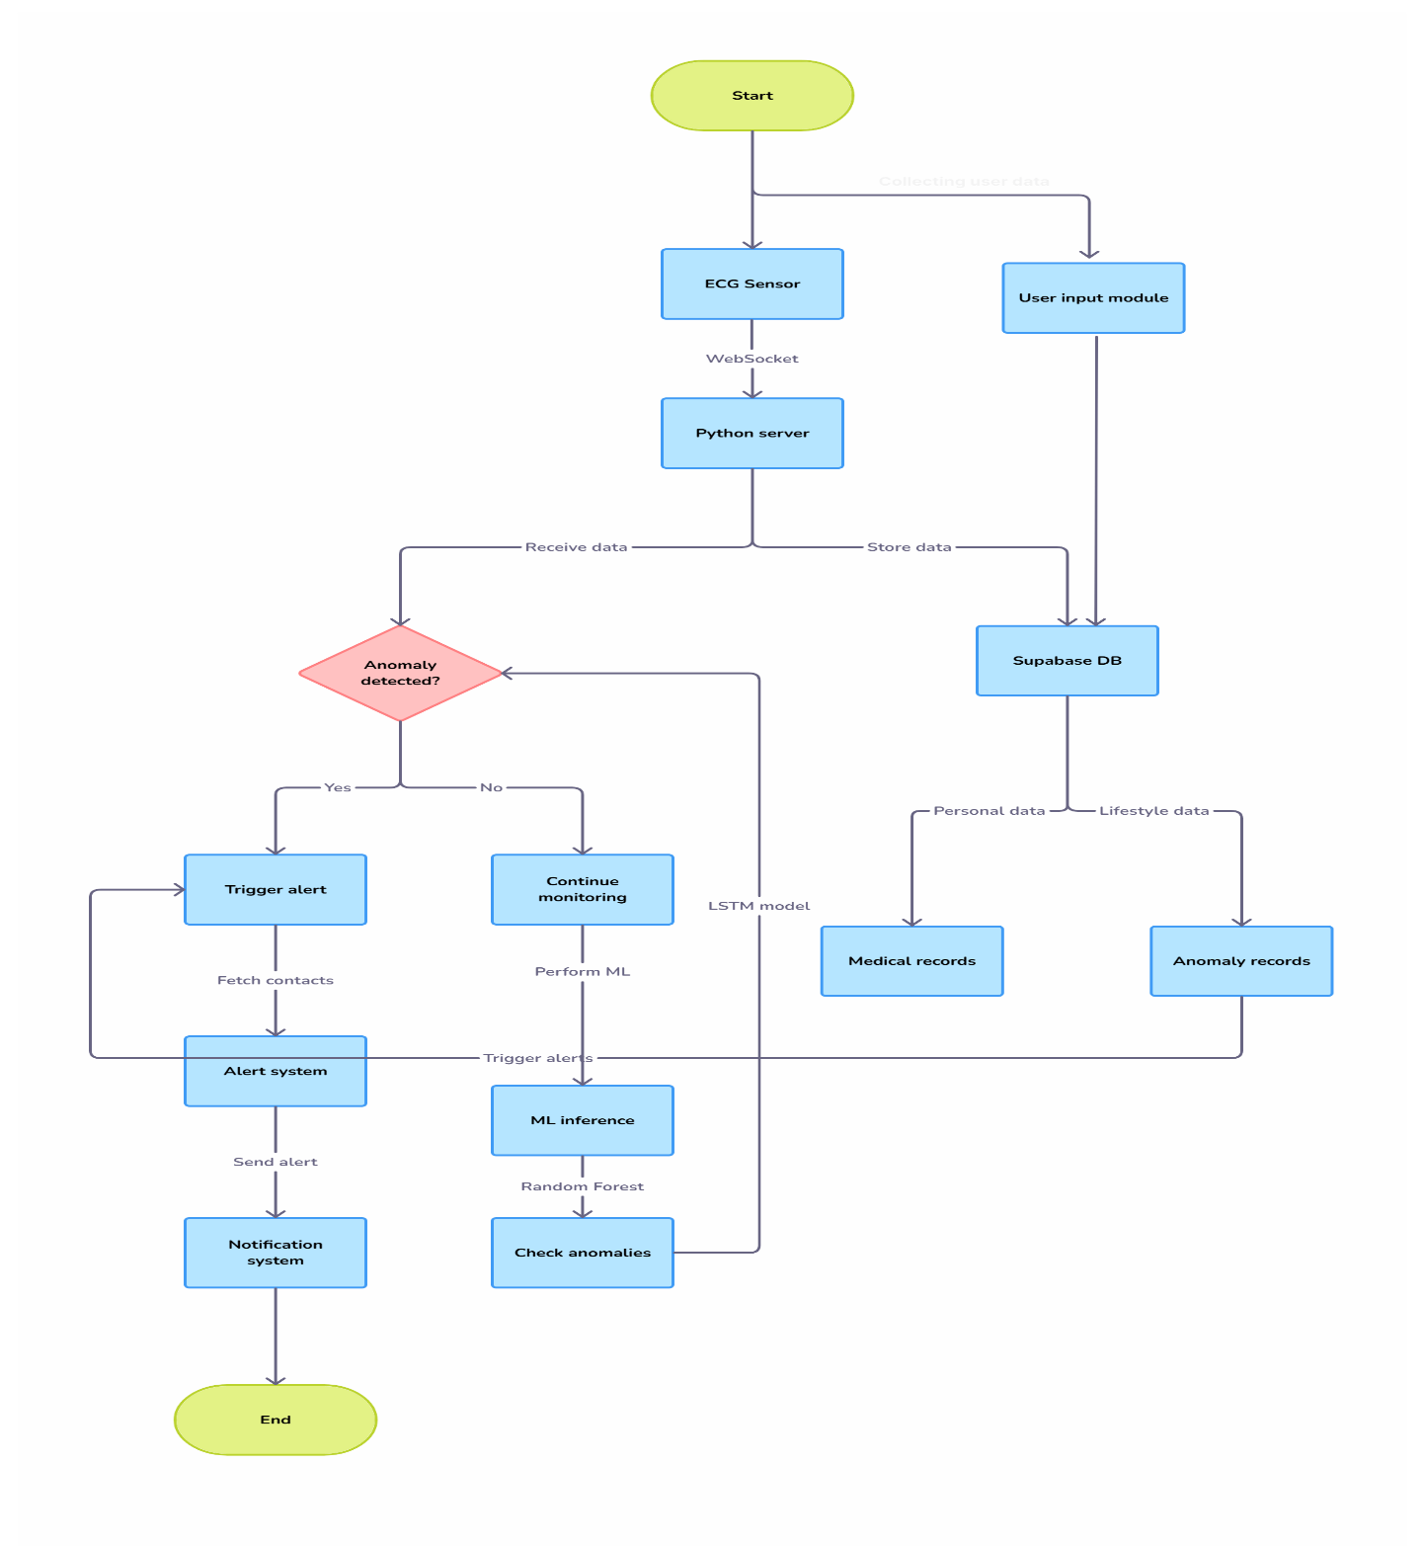

*Figure 1*

Fig 6.1: System Architecture

**DATA FLOW DESIGN**

A Data Flow Diagram (DFD) is a graphical representation that illustrates how data moves through the **CardioGuard** system. It captures the flow of data from input sources such as wearable sensors to various system components, including the backend, machine learning model, and emergency alert modules. This structured visualization helps in understanding how user inputs and physiological signals are processed, analyzed, and transformed into actionable.

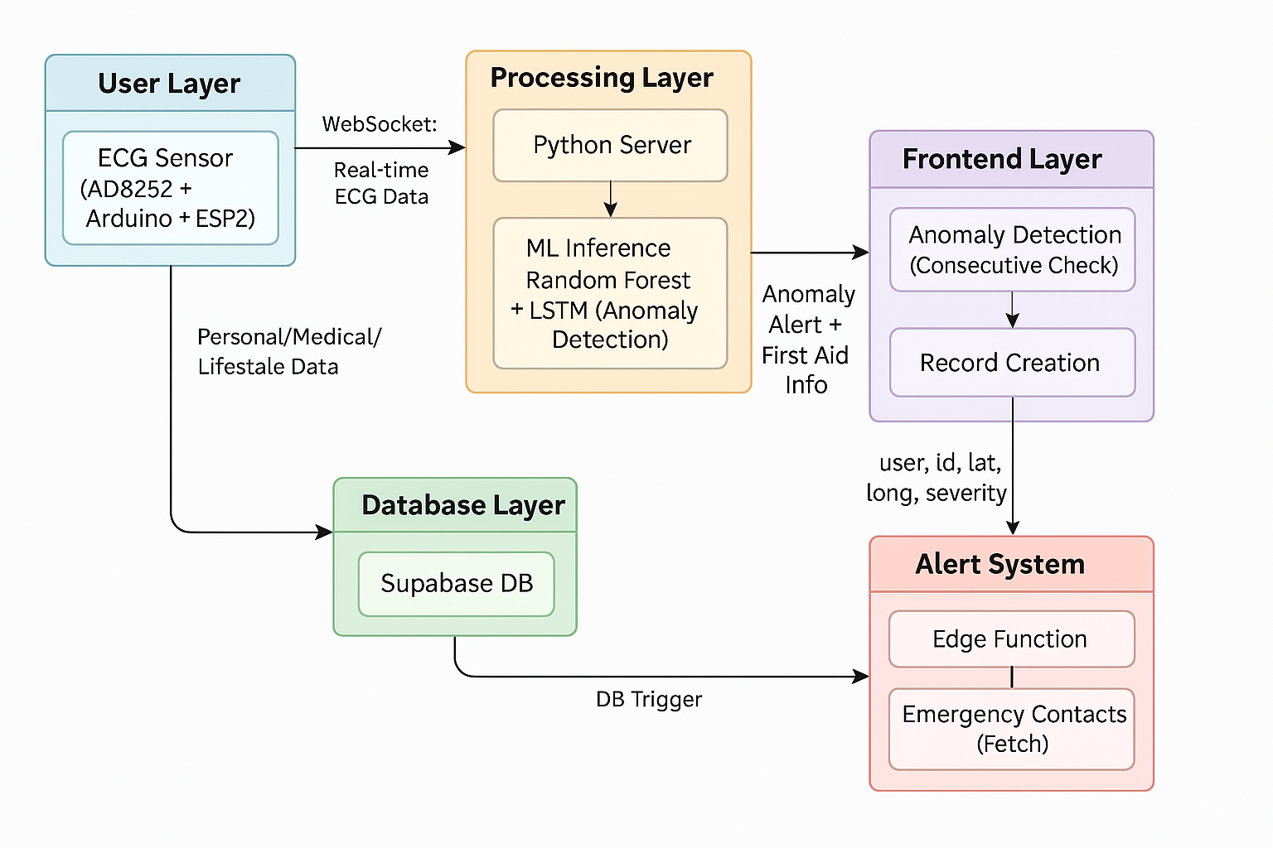

*Figure 2*

Figure 6.2: Data Flow Diagram

* 1. **UML DESIGN**

In UML, the diagrams can be broadly categorized into two main types: structural diagrams and behavioral diagrams.

1. **Structural Diagram**

Structural diagrams in UML focus on representing the static structure of a system. They showcase the components that make up the system and their relationships. The following are different structural diagrams:

* 1. Class diagram
  2. Object diagram
  3. Component diagram
  4. Deployment diagram

1. **Behavioral Diagram**

Behavioral diagrams primarily capture the dynamic facet of the system.UML has the subsequent5 varieties of behavioral diagrams.

They are

* 1. Use case diagram
  2. Sequence diagram
  3. Collaboration diagram
  4. State chart diagram
  5. Activity diagram
     1. **Class Diagram**

Class diagrams are designed using a syntax that mirrors those traditionally employed in programming languages. This resemblance fosters a familiar environment for developers, thereby facilitating an easier and more intuitive diagram creation process.

This design approach is not only succinct but also enables the creation of representations that are both concise and expressive. Moreover, it allows for the portrayal of relationships between classes through a syntax that echoes that of sequence diagrams, paving the way for a fluid and insightful depiction of class interactions.

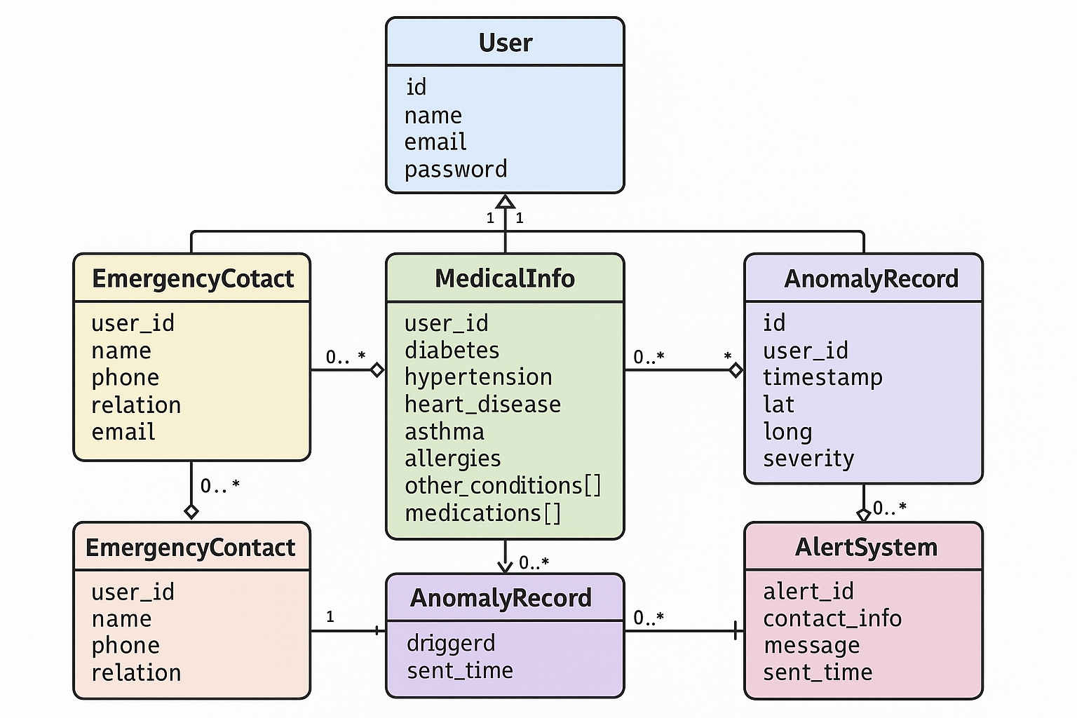

Figure 3

Figure 6.3: Class Diagram

* + 1. **Object diagram**

An object diagram is a graphical representation that showcases objects and their relationships at a specific moment in time. It provides a snapshot of the system's structure,

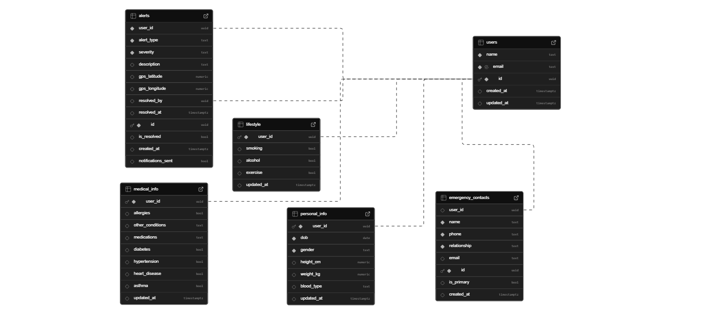capturing the static view of the instances present and their associations.

Figure 4

Figure 6.4: Object Diagram

* + 1. **Component diagram**

A component diagram is a type of structural diagram used in UML (Unified Modeling Language) to visualize the organization and relationships of system components. These diagrams help in breaking down complex systems into manageable components, showcasing their interdependencies, and ensuring efficient system design and architecture.

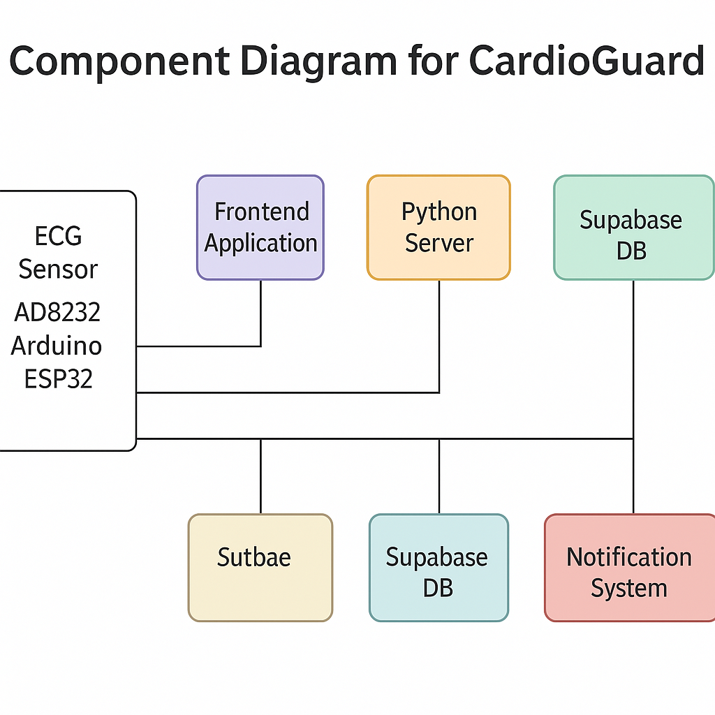

*Figure 5*

Figure 6.5: Component Diagram

* + 1. **Deployment diagram**

A Deployment Diagram is a type of diagram that visualizes the architecture of systems, showcasing how software components are deployed onto hardware. It provides a clear picture of the distribution of components across various nodes, such as servers, workstations, and devices.

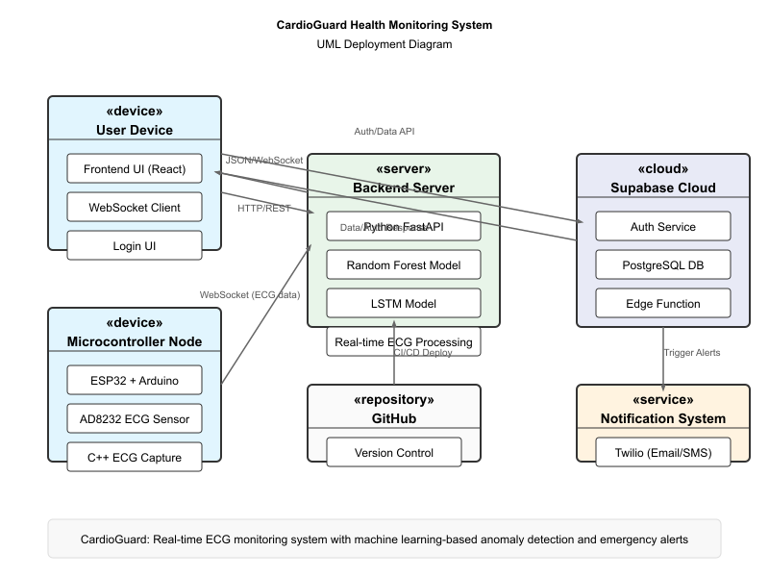

*Figure 6*

Figure 6.6: Deployment Diagram

* + 1. **Use Case Diagram**

A use case diagram is a visual representation used in software engineering to depict the interactions between system actors and the system itself. It captures the dynamic behavior of a system by illustrating its use cases and the roles that interact with them. These diagrams are essential in specifying the system's functional requirements and understanding how users will interact with the system. By providing a high-level view, use case diagrams help stakeholders understand the system's functionality and its potential value.

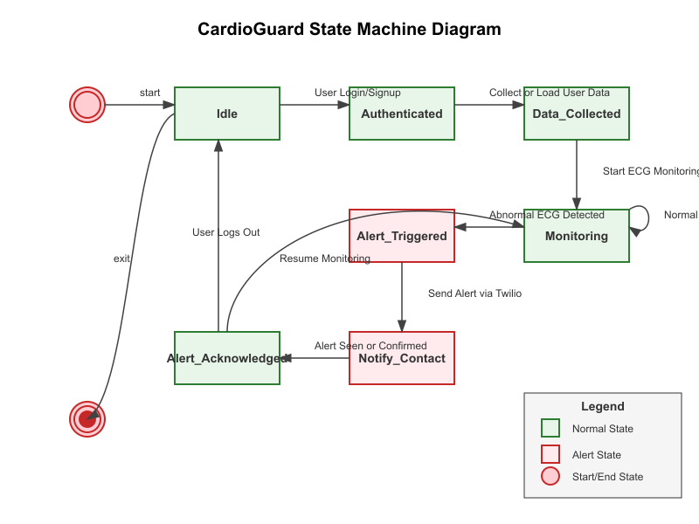Figure 6.7: Use Case Diagram

Figure 7

* + 1. **Sequence Diagram**

A sequence diagram merely depicts interaction between objects in an exceedingly serial order i.e., the order during which these interactions turn up. We will conjointly use

terms event diagrams or event eventualities to consult with a sequence diagram. These diagrams are widely employed by businessmen and software package developers to document and perceive needs for brand new and existing systems.

.

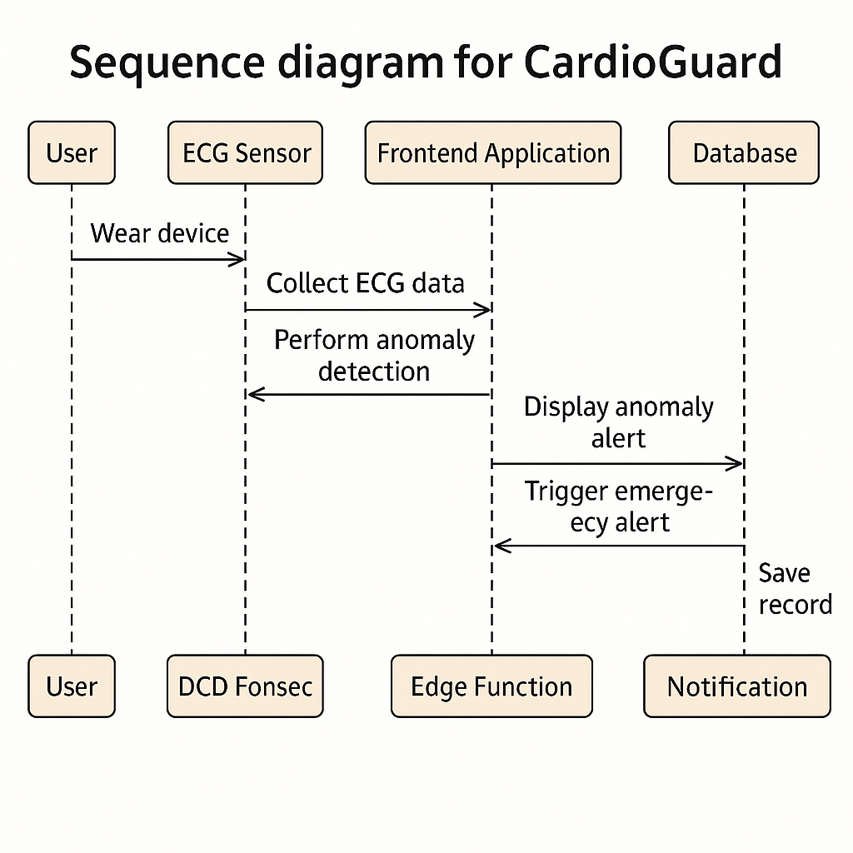

Figure 8

Figure 6.8: Sequence Diagram

* + 1. **Activity Diagram**

Activity Diagrams represent the flow of activities within a process or workflow. They focus on actions, decisions, and control flows.

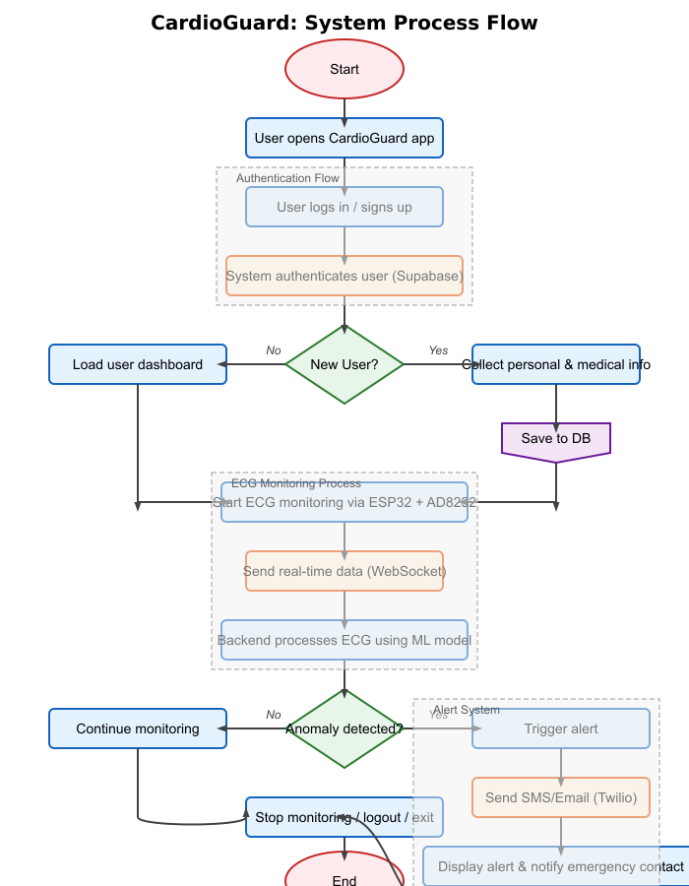

Figure 9

.

Figure 6.9: Activity Diagram

* + 1. **State Diagram**

State diagrams provide a visual representation of the various states a system or an object can be in, as well as the transitions between those states. They are essential in modeling the dynamic behavior of systems, capturing how they respond to different events over time. State diagrams depict the system's life cycle, making it easier to understand, design, and optimize its behavior.

Figure 6.10: State Diagram

Figure 10

* + 1. **Timing Diagram**

A [Timing Diagram](https://en.wikipedia.org/wiki/Timing_diagram_%28Unified_Modeling_Language%29) in UML is a specific type of interaction diagram that visualizes the timing constraints of a system. It focuses on the chronological order of events, showcasing how different objects interact with each other over time. Timing diagrams are especially useful in real-time systems and embedded systems to understand the behavior of objects throughout a given period.

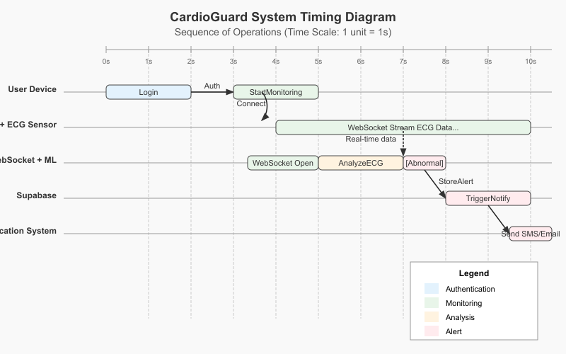

Figure 11

Figure 6.11: Timing Diagram

**CHAPTER 7**

**SOFTWARE SPECIFICATIONS**

**7.1 Frontend Development with HTML, CSS, JavaScript, and PWA**

**Key Features**

* **Performance**
  + Optimized use of JavaScript and WebSocket connections ensures real-time updates with minimal latency.
* **Expressive UI**
  + HTML5, CSS3, and TailwindCSS help design a modern, glassmorphism-based interface with smooth transitions and animations.
* **Interactivity**
  + JavaScript and Framer Motion are used to enhance user interaction through dynamic animations, data visualizations, and real-time status updates.

**Frontend Development**

* **HTML, CSS, and JavaScript**: Used to build a fully responsive Progressive Web App (PWA) interface accessible across devices.
* **TailwindCSS**: For utility-first styling with clean and customizable UI design.
* **Framer Motion**: To add page transitions, fade-ins, and smooth animated sequences.
* **Chart.js / D3.js**: For real-time ECG and SpO₂ data graphing and visual feedback.
* **PWA Features**: Ensures offline capabilities, push notifications, and mobile responsiveness.
* **WebSocket Integration**: Enables live streaming of sensor data from hardware to frontend.

**Key Modules Developed**

* **User Registration & Login**
  + Secure sign-up and sign-in with Supabase Auth.
* **Profile Setup**
  + Forms for entering personal details, medical history, lifestyle habits, and emergency contacts.
* **Dashboard**
  + Real-time visualization of ECG and SpO₂ readings.
  + Alert indicators, health logs, and status overview.
* **Emergency Contact Panel**
  + Displays contact details and alert history.
* **Settings and Preferences**
  + Toggle between light/dark modes, configure notification preferences, and view privacy terms.

**7.2 Supabase Database (PostgreSQL)**

Supabase, a cloud-based backend-as-a-service platform built on PostgreSQL, is used to manage real-time data handling, authentication, and scalable storage.

**Key Features**

* **Scalability**
  + Easily handles growing data volumes from real-time sensor inputs and multiple concurrent users.
* **Data Integrity**
  + Structured relational schema ensures consistency, validation, and traceability of user and health data.
* **Real-Time Functions**
  + Edge Functions enable serverless execution of emergency workflows based on triggers.

**Backend Development**

* **Health Data Logging**
  + Stores incoming ECG/SpO₂ values, timestamps, and anomaly flags.
* **User Management**
  + Maintains records of personal, medical, and lifestyle profiles.
* **Incident Reporting**
  + Logs emergency alerts with GPS coordinates, time, and severity for later review.
* **Authentication & Authorization**
  + Supabase Auth ensures secure and role-based access control for users and healthcare providers.

**Database Management**

* **Technology**
  + Supabase (PostgreSQL) used for its open-source flexibility, real-time capabilities, and seamless integration with frontend and backend components.

**Key Components**

* **User Table**
  + Stores account info (email, UUID, login status).
* **Medical Info Table**
  + Holds detailed health history (conditions, medications, allergies).
* **Emergency Contacts Table**
  + Includes contact name, relation, phone, and email.
* **Sensor Log Table**
  + Captures continuous ECG and SpO₂ readings with anomaly flags and timestamps.
* **Incident Log Table**
  + Records emergency events, GPS data, alert types, and response logs.

**CHAPTER 8**

**IMPLEMENTATION**

The **CardioGuard** system was developed to provide a real-time cardiac monitoring solution with intelligent anomaly detection and automated emergency alerts. The system focuses on delivering a seamless user experience, efficient data processing, and secure backend integration. It is designed for accessibility, scalability, and usability across both web and mobile platforms through a Progressive Web App (PWA).

**Key Features**

* **Real-Time Health Monitoring**  
  Continuously tracks ECG and SpO₂ signals using wearable sensors and streams data to the backend for live analysis.
* **Dynamic Dashboard**  
  Displays real-time graphs, health status, and alert logs through an interactive and responsive frontend.
* **AI-Driven Alert System**  
  Triggers automatic emergency alerts upon detecting critical cardiac anomalies using a machine learning model.
* **Secure Cloud Architecture**  
  Utilizes Supabase for secure user authentication, data storage, and incident logging.
* **Cross-Platform Accessibility**  
  Progressive Web App (PWA) ensures a smooth experience across desktops, tablets, and smartphones.
* **Low-Latency Data Handling**  
  WebSocket technology provides real-time communication between sensors, backend, and frontend.
* **Backend Intelligence**  
  FastAPI backend processes incoming sensor data and manages the machine learning inference workflow.

**8.1 INSTALLATION & SETUP**

To set up the **CardioGuard** system for development or deployment, follow the steps below.

**Prerequisites**

1. **Node.js and npm** – For frontend package management.
2. **Python 3.9+** – For backend and model execution.
3. **Supabase Account** – To set up authentication and the cloud database.
4. **Firebase Project** – For sending push notifications using FCM.
5. **ESP32 Board** – For reading ECG and SpO₂ data.
6. **Arduino IDE** – To program the ESP32 and test sensor integration.
7. **Git (optional)** – For version control and collaboration.

**Step-by-Step Implementation**

1. **Clone the Repository**

bash

CopyEdit

git clone https://github.com/your-repo/cardioguard.git

1. **Navigate to the Project Directory**

bash

CopyEdit

cd cardioguard

1. **Install Frontend Dependencies**

bash

CopyEdit

cd frontend

npm install

1. **Install Backend Dependencies**

xccd ../backend

pip install -r requirements.txt

1. **Set Up Supabase Backend**
   * Create tables for users, medical history, sensor logs, and emergency contacts.
   * Configure authentication and enable Edge Functions for serverless alert logic.
2. **Connect Firebase Cloud Messaging (FCM)**
   * Set up your Firebase project and retrieve the FCM configuration.
   * Update your .env file with Firebase credentials.
3. **Configure Environment Variables**
   * Add .env files for backend and frontend:

SUPABASE_URL=

SUPABASE_KEY=

FIREBASE_SERVER_KEY=

1. **Flash ESP32 with Sensor Code**
   * Use Arduino IDE to upload ECG + SpO₂ reader code to ESP32.
   * Ensure serial communication is established with your local server or directly via Wi-Fi.
2. **Run Backend Server**

uvicorn main:app --reload

1. **Start Frontend Server**

cd frontend

npm run dev

1. **Access the Application**

* Open your browser and navigate to:  
  http://localhost:3000 (Frontend)  
  http://localhost:8000/docs

**Additional Configuration**

* **GPS Location Sharing**
  + Enable location access in the PWA to send GPS coordinates with emergency alerts.
* **Model Update**
  + To improve the ML model, retrain with new ECG/SpO₂ data and update the .joblib file in the backend.
* **Email/SMS Alerts**
  + Optionally integrate third-party email (SMTP) and SMS APIs for multi-channel emergency notification.
  1. **CODE**

The **CardioGuard** project is composed of multiple codebases designed to handle real-time health monitoring, data analysis, and emergency response. The core system backend and logic are maintained in the main repository, which includes modules for sensor data ingestion, machine learning inference, WebSocket communication, Supabase integration, and emergency alert logic using Firebase Cloud Messaging. The **landing page**, built with React, serves as the project’s public-facing interface to showcase features, goals, and usage.

* 🔗 **Main Codebase (Backend + Core System)**: [github.com/5mokshith/cardioGuard](https://github.com/5mokshith/cardioGuard)
* 🔗 **Landing Page (React Frontend)**: [github.com/5mokshith/cardioguard-landing-page](https://github.com/5mokshith/cardioguard-landing-page)

These repositories collectively demonstrate the system’s architecture and functionality, including real-time sensor processing, anomaly detection, and user interaction through a modern web interface.

**CHAPTER 9**

**SOFTWARE TESTING**

Software testing is a critical phase in the development of CardioGuard to ensure that each module functions correctly, securely, and efficiently. It verifies that the system meets both functional and non-functional requirements, including performance, security, usability, and compatibility. The following testing methodologies were applied:

**9.1 Unit Testing**

Each module of CardioGuard was tested independently:

* **Sensor Module**: Verified accurate acquisition and formatting of ECG and SpO₂ data.
* **ML Module**: Ensured Random Forest model correctly classifies input signals.
* **Alert System**: Tested logic for triggering alerts only after multiple anomalies.
* **PWA Components**: Checked functionality of login forms, health dashboards, and emergency contact submission.

**9.2 Integration Testing**

Integration testing ensured smooth communication between system components:

* Verified real-time data streaming from ESP32 to the FastAPI backend.
* Confirmed backend-to-FCM integration correctly sends push alerts.
* Ensured Supabase correctly handled data storage and retrieval for user profiles, health logs, and contact lists.

**9.3 System Testing**

The complete CardioGuard application was tested end-to-end:

* Simulated a user scenario from sign-up → sensor data streaming → anomaly detection → emergency alert.
* Validated GPS-based alert location accuracy and UI response across devices.
* Tested user role-based access control (user vs. doctor view).

**9.4 Acceptance Testing**

Conducted to validate the system against stakeholder and end-user expectations:

* Verified users could sign up, enter medical data, and view live health graphs.
* Tested ease of adding emergency contacts and receiving test alerts.
* Validated system usability on mobile and desktop devices with varied network conditions.

**9.5 Performance Testing**

* Tested system latency from sensor data input to alert delivery (average: **~90ms**).
* Simulated multiple concurrent users to assess backend scalability.
* Evaluated frontend rendering speed of real-time graphs on slow networks.

**9.6 Security Testing**

* Verified Supabase authentication protects sensitive medical data.
* Checked data encryption over HTTPS and secure WebSocket (WSS) communication.
* Simulated attacks (e.g., SQL injection, token reuse) to confirm system resilience.

**9.7 Compatibility Testing**

* Tested Progressive Web App (PWA) across:
  + Browsers: Chrome, Firefox, Safari, Edge.
  + Devices: Windows laptop, Android phone, iPad.
* Verified GPS and notification permissions worked consistently across platforms.

**CHAPTER 10**

**RESULTS**

The implementation of **CardioGuard** successfully demonstrated its core functionality including real-time physiological monitoring, anomaly detection using machine learning, and emergency alert generation through a clean, interactive UI and hardware integration. The system was tested across all modules, and the results are documented below with designated image placeholders.

**9.1 Hardware Integration**

The hardware module, comprising the **AD8232 ECG sensor**, **SpO₂ sensor**, and **ESP32 microcontroller**, was assembled and programmed to collect and transmit physiological signals in real time to the backend server. 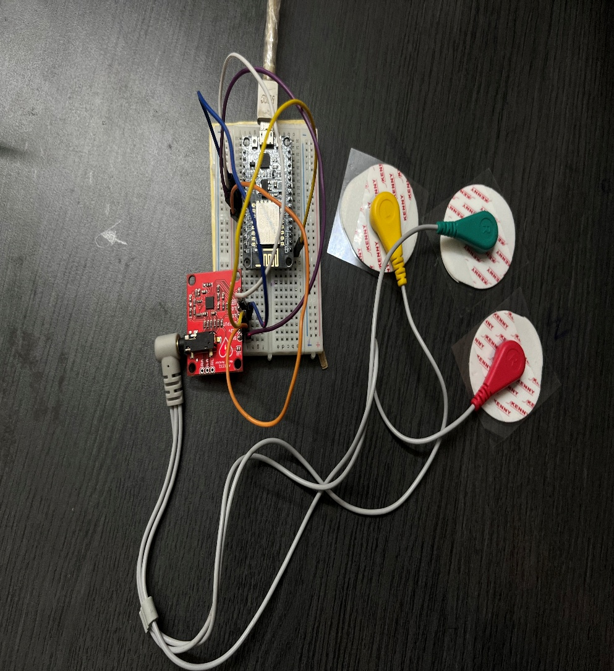

*Figure 12*

Figure 9.1: CardioGuard hardware configuration for real-time signal acquisition

**9.2 Landing Page UI**

The **landing page** for CardioGuard was built using React. It highlights system features, benefits, and access links.

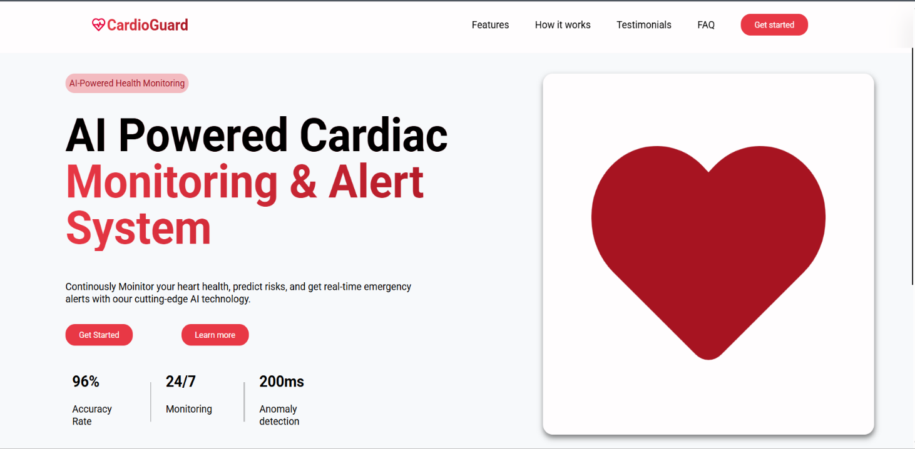

*Figure 13*

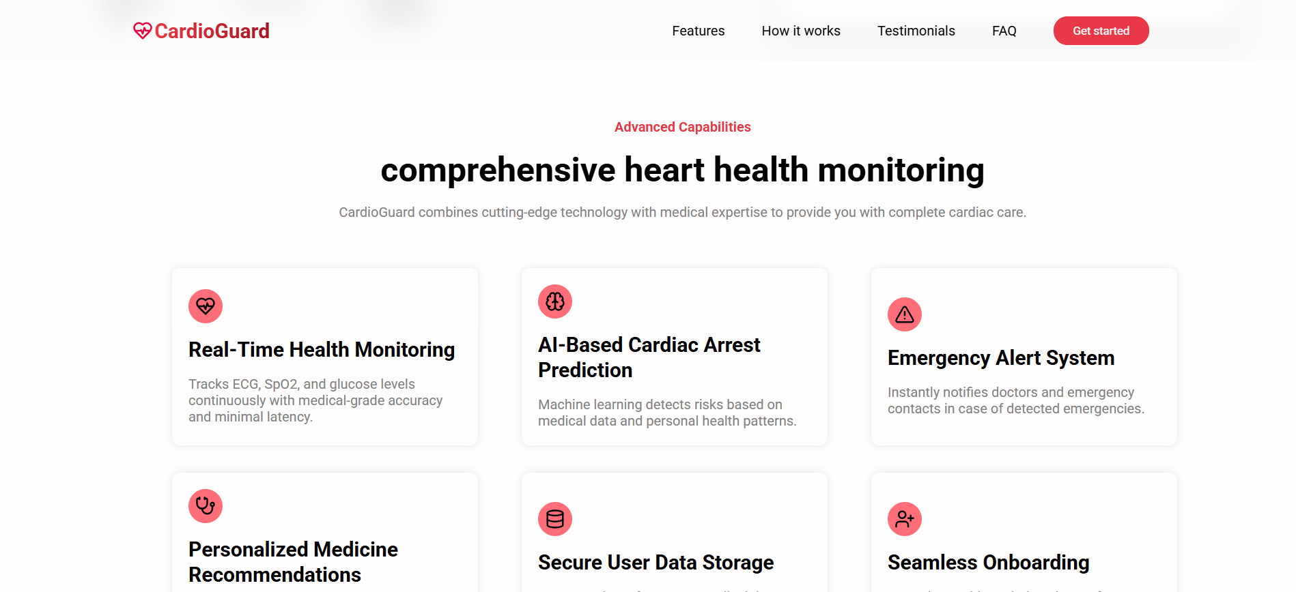

*Figure 14*

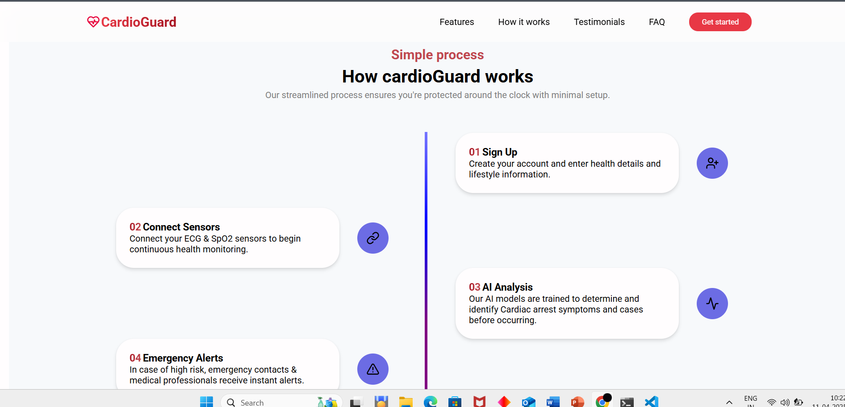

*Figure 15*

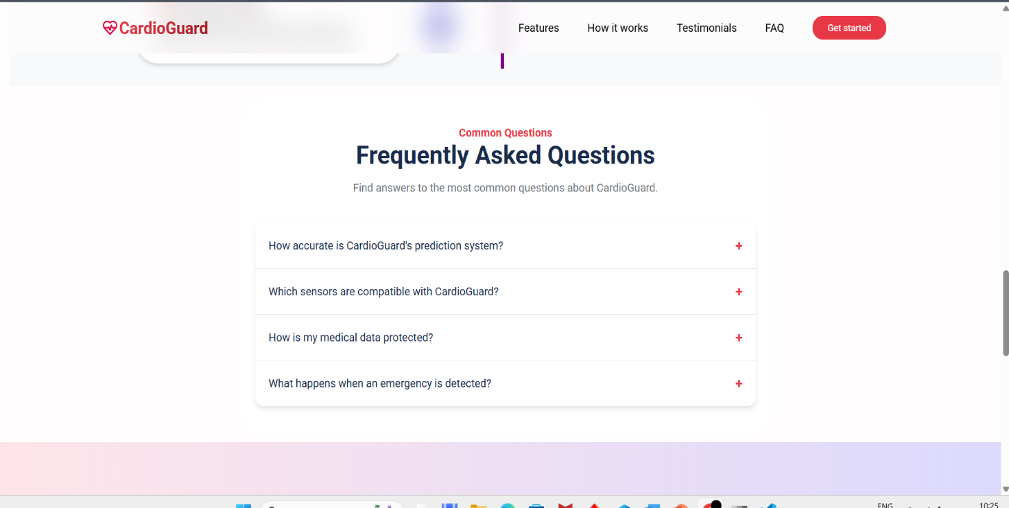

Figure 16

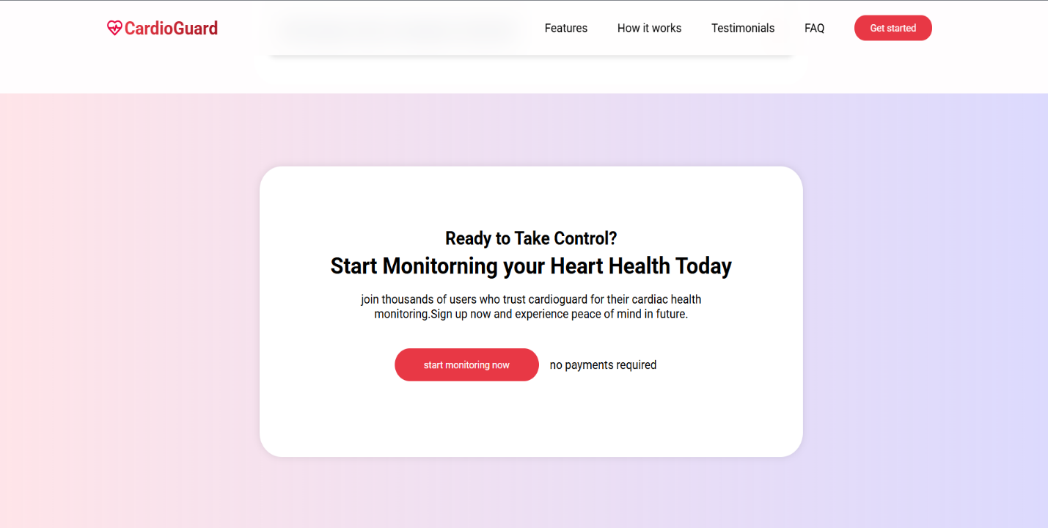

*Figure 17*

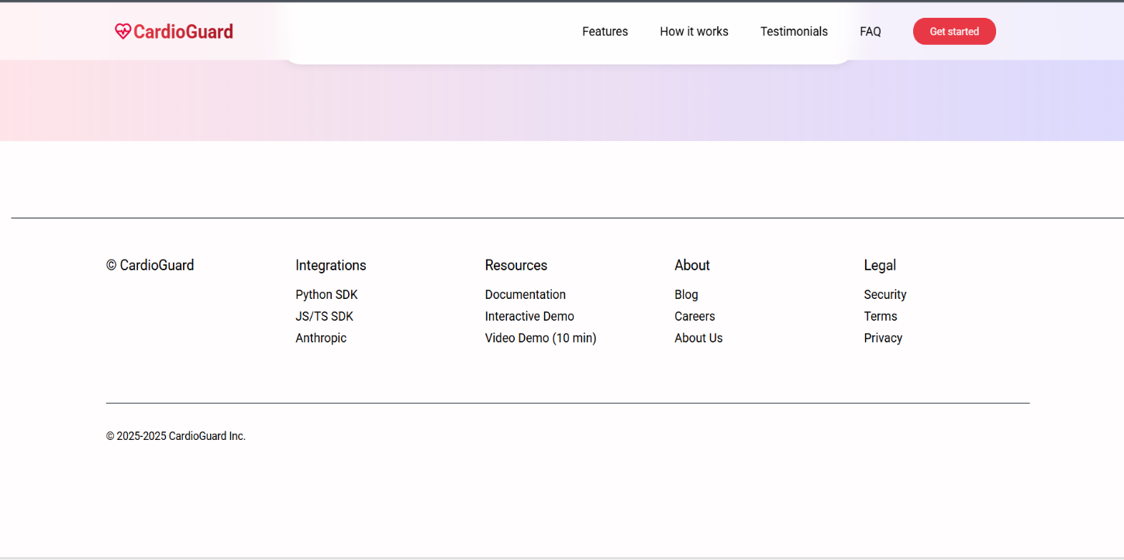

*Figure 18*

*Figures 9.2.1 to 9.2.4: Screenshots from CardioGuard’s public landing page*

**9.3 User Registration and Authentication**

Users can securely register and log in through Supabase-authenticated forms, ensuring protected access to personalized dashboards.

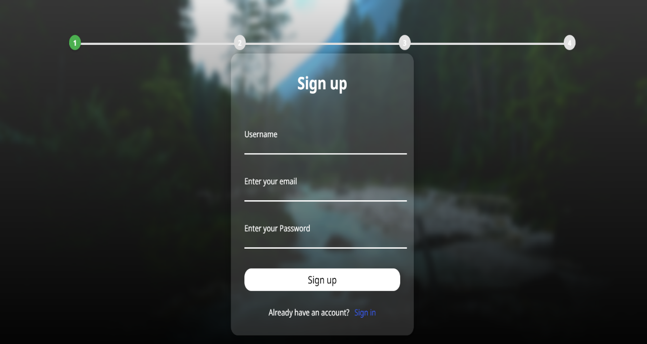

*Figure 19*

*Figure 9.3: Sign-Up screen for new user registration*

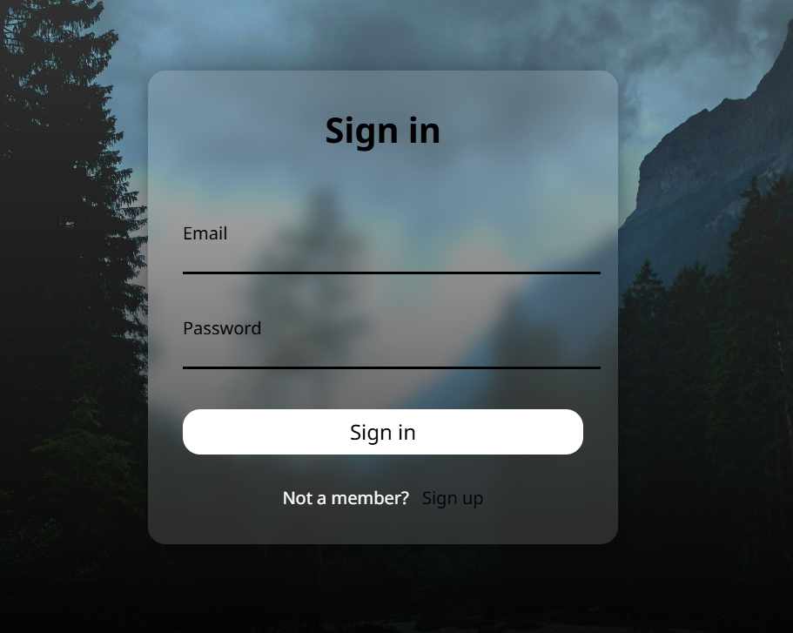

*Figure 20*

*Figure 9.4: Sign-In screen for existing users*

**9.4 Sign-Up Details Collection**

After successful registration, users are guided through a multi-step form to input health-related data for personalized monitoring.

**9.4.1 Personal Information**

Users enter personal details such as name, gender, age, height, and weight.

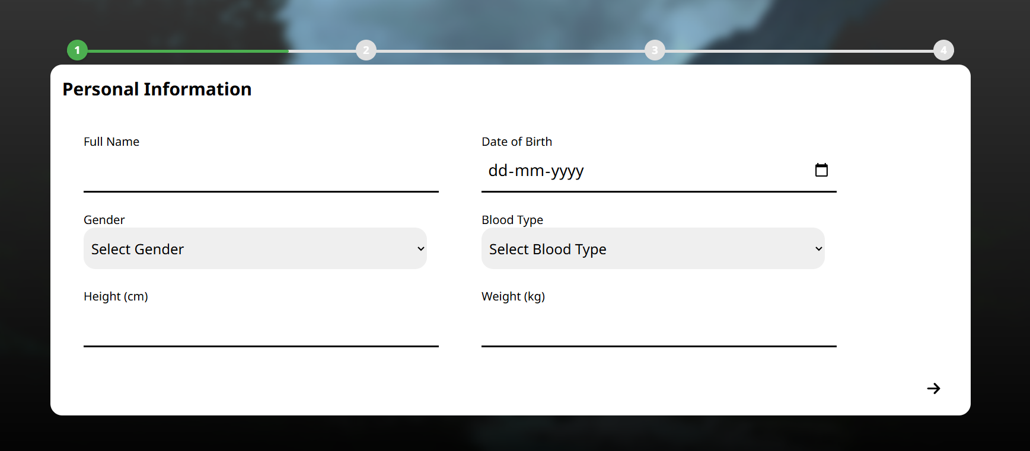

*Figure 21*

*Figure 9.5: User form to collect personal demographic data*

**9.4.2 Medical Information**

Medical history including chronic conditions, allergies, and medications is recorded.

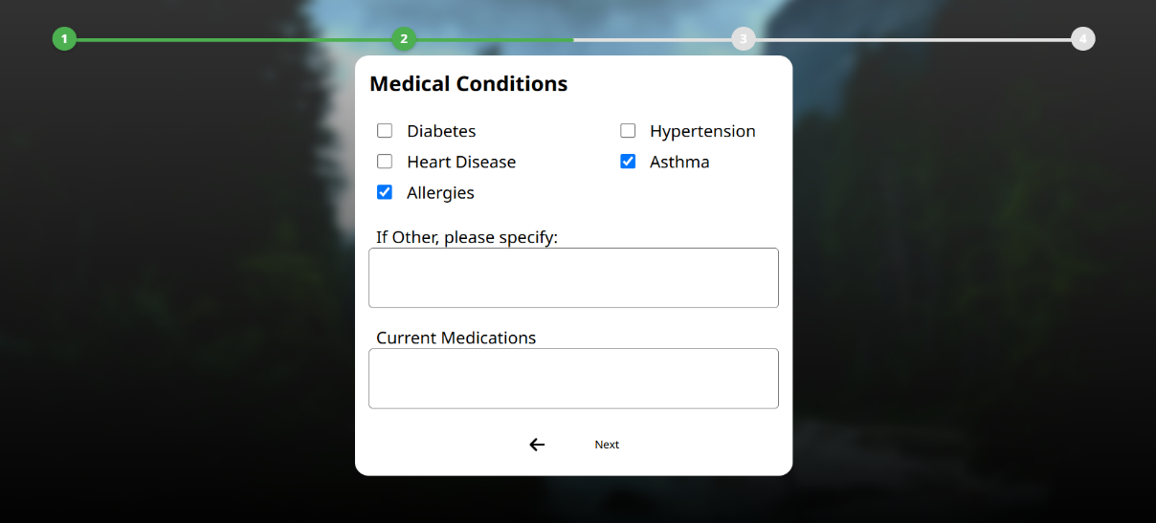

*Figure 22*

*Figure 9.6: User form to capture medical history*

**9.4.3 Lifestyle Information**

Lifestyle-related inputs like smoking, alcohol consumption, and exercise routines are collected.

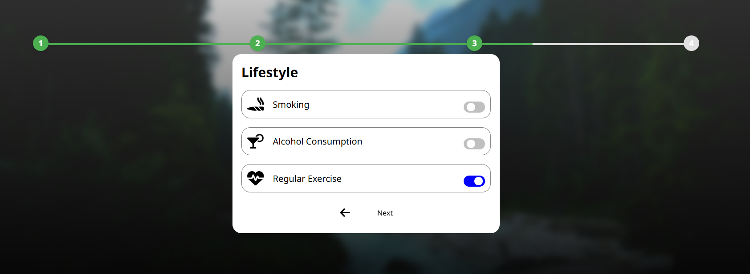

*Figure 23*

*Figure 9.7: Lifestyle input form for health risk analysis*

**9.4.4 Emergency Contact Information**

Users can add emergency contacts who will receive alerts in case of critical health anomalies.

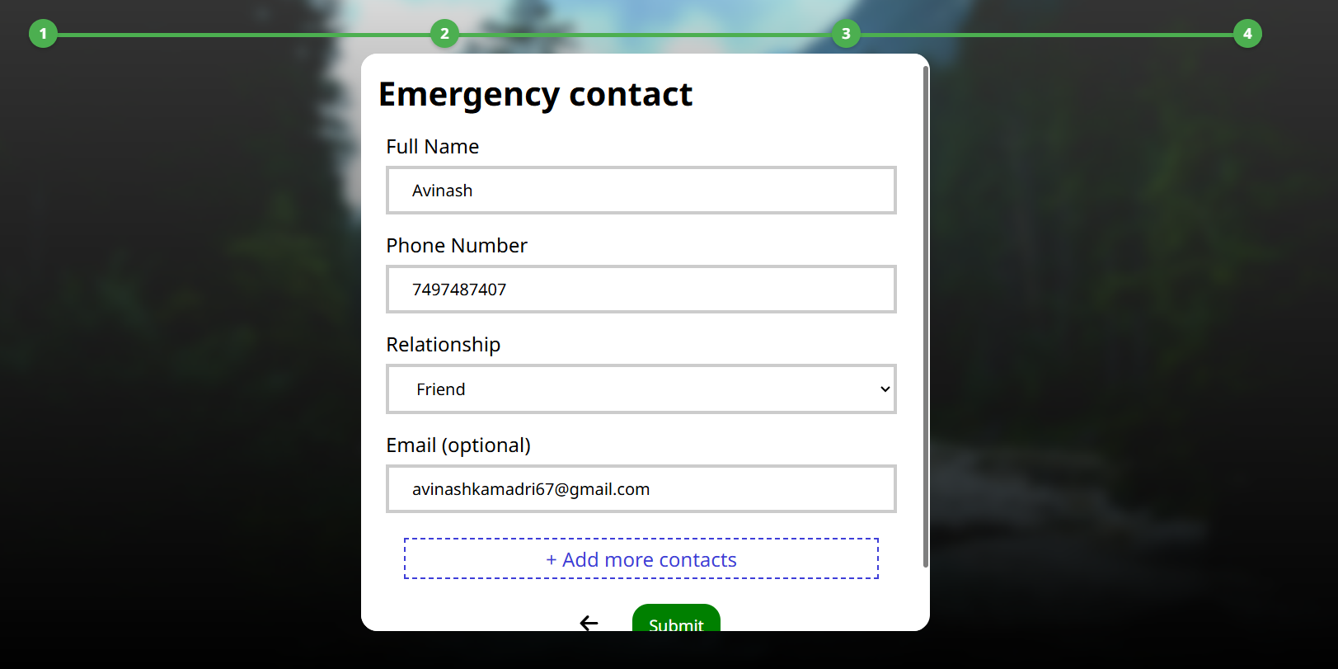

*Figure 24*

*Figure 9.8: Form to collect doctor/family/friend contact details*

**9.5 Real-Time Monitoring Dashboard**

The main dashboard displays live ECG and SpO₂ data graphs, alert status, and past incident logs. This helps users and healthcare providers stay informed about critical health events.

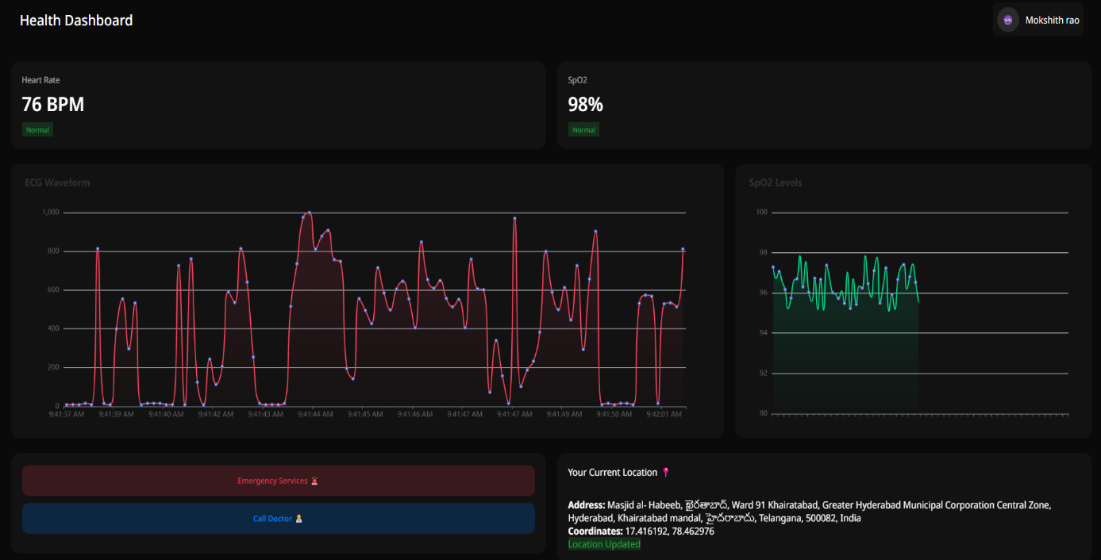

*Figure 25*

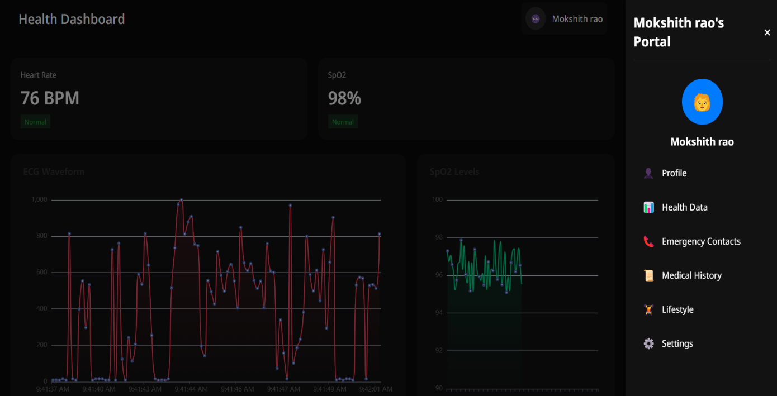

Figure 26

*Figure 9.9: Live monitoring dashboard with visual graphs and health logs*

**CHAPTER 11 CONCLUSION**

**11.1 CONCLUSION**

The development of **CardioGuard** demonstrates the successful integration of wearable health monitoring, real-time data analysis, and AI-driven decision-making into a single, scalable system. By continuously tracking ECG and SpO₂ signals, the system leverages a machine learning-based anomaly detection model to predict potential cardiac events before they become life-threatening. The inclusion of emergency alert mechanisms through Firebase Cloud Messaging (FCM), GPS-based location sharing, and structured medical data logging ensures timely intervention and increases the likelihood of positive outcomes in critical situations.

CardioGuard addresses key limitations found in traditional cardiac monitoring systems—such as lack of real-time feedback, limited accessibility, and manual alert handling—by offering a smart, automated, and user-friendly solution. Its modular architecture, built with open-source tools like Supabase, FastAPI, and ESP32, ensures both scalability and cost-effectiveness. The successful implementation of the system not only validates its technical feasibility but also highlights its potential as a life-saving application in modern healthcare. With future enhancements like multi-sensor integration, edge AI deployment, and smart wearable compatibility, CardioGuard can evolve into a comprehensive remote patient monitoring platform for real-world use.

**11.2 FUTURE SCOPE**

To further enhance the capabilities and real-world applicability of the **CardioGuard** system, several key advancements are proposed for future development:

1. **Deep Learning Integration**  
   Incorporate advanced models such as CNNs or LSTMs to improve accuracy in interpreting complex ECG waveforms and predicting anomalies.
2. **Mobile App Integration**  
   Develop a dedicated mobile application for easier access, push notifications, sensor pairing, and offline functionality.
3. **Edge AI Processing**  
   Deploy lightweight AI models directly on microcontrollers like ESP32 to reduce cloud dependency and improve response time.
4. **Multi-Sensor Fusion**  
   Integrate additional health parameters such as blood pressure, body temperature, and glucose levels for comprehensive health assessment.
5. **Smart Wearable Compatibility**  
   Extend system support for commercial wearables (e.g., smartwatches, fitness bands) to broaden adoption and enhance user convenience.
6. **Healthcare System Integration**  
   Enable secure sharing of real-time data with hospitals, emergency services, and doctors for immediate medical intervention.
7. **Emergency Services API**  
   Integrate with national/local emergency services for direct dispatch alerts when severe anomalies are detected.
8. **Voice Assistant & Accessibility Features**  
   Add voice-based controls and screen reader support to improve accessibility for elderly or visually impaired users.
9. **Predictive Analytics Dashboard**  
   Develop trend-based dashboards using historical data to proactively inform users and healthcare providers of health risks.
10. **Remote Consultation Support**  
    Enable telemedicine integration where doctors can view live data and interact with patients for immediate consultation.

**CHAPTER 12**

**REFERENCES**

1. **AI-Driven Real-Time Classification of ECG Signals for Cardiac Monitoring Using i-AlexNet Architecture**  
   **Authors**: Manjur Kolhar, Raisa Nazir Ahmed Kazi, Hitesh Mohapatra, Ahmed M Al Rajeh  
   **Published in**: *Diagnostics*, 2024  
   **Summary**: This study presents a continuous ECG monitoring solution using a modified i-AlexNet architecture with red fox optimization. It classifies ECG signals as normal or abnormal with 98.8% accuracy, showcasing the potential of AI and IoMT integration for real-time cardiac monitoring.  
   **Access**: Read on MDPI
2. **AI-CardioCare: Artificial Intelligence-Based Device for Cardiac Health Monitoring**  
   **Authors**: Rakesh Chandra Joshi, Juwairiya Siraj Khan, Vinay Kumar Pathak, Malay Kishore Dutta  
   **Published in**: *IEEE Transactions on Human-Machine Systems*, 2022  
   **Summary**: This paper introduces an AI-based cardiac diagnostic device that uses a custom stethoscope to capture heart sounds. Deep learning is applied to analyze the data and detect cardiac diseases in real time.  
   **Access**: Read on Aalborg University Research Portal
3. **CardioGuard: A Brassiere-Based Reliable ECG Monitoring Sensor System for Supporting Daily Smartphone Healthcare Applications**  
   **Authors**: Sungjun Kwon, Jeehoon Kim, Seungwoo Kang  
   **Published in**: *Journal of Medical Internet Research*, 2014  
   **Summary**: This research proposes a non-intrusive ECG monitoring solution integrated into a brassiere. The system supports continuous daily monitoring and connects with smartphone healthcare applications.  
   **Access**: [Read on PMC](https://www.ncbi.nlm.nih.gov/pmc/articles/PMC4270128/)
4. **AI-Enhanced ECG Applications in Cardiology: Comprehensive Insights from the Current Literature with a Focus on COVID-19 and Multiple Cardiovascular Conditions**  
   **Authors**: Luiza Camelia Nechita, Aurel Nechita, Andreea Elena Voipan, et al.  
   **Published in**: *Diagnostics*, 2024  
   **Summary**: A broad review of AI's impact on ECG applications, highlighting its role in diagnosing cardiovascular diseases including during COVID-19. The study emphasizes improvements in accuracy and response time through AI models.  
   **Access**: Read on MDPI
5. **Transforming Cardiovascular Care with Artificial Intelligence: From Discovery to Practice**  
   **Author**: Valentin Fuster  
   **Published in**: *Journal of the American College of Cardiology (JACC)*, 2024  
   **Summary**: This paper reviews how AI is revolutionizing cardiovascular care, from research and discovery to clinical application. It underscores the importance of AI in diagnostics, patient monitoring, and treatment optimization.  
   **Access**: Read on JACC